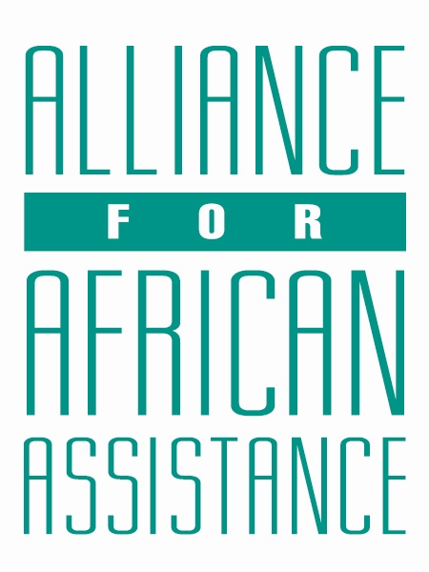
CSP Child Biography Form

PERSONAL INFORMATION
Child’s Village  (Where he/she currently lives) | OBIYA EAST
Child’s District  (Where he/she currently lives) | GULU
Child’s County  (Where he/she currently lives) | BARDEGE-LAYIBI
Child’s Christian Name | BRIAN AUSTINE
Child’s Acholi Name | RUBANAGAKENE
Child’s Date of Birth | 15/06/2005
Child’s Gender | MALE
Child’s Favorite Game/Activity | FOOTBALL

FAMILY INFORMATION
Mother’s Name | AMONO MONICA DOREEN
Is mother alive? | ALIVE
Mother’s Profession, if living.  (If farming, which crops are presently being grown?) | COMPOUND CLEANER AT A PRIMARY SCHOOL
Father’s Name | ORINGA JAMES
Is father alive? | DECEASED
Father’s Profession, if living.
(If farming, which crops are presently being grown?)
If both parents are living, please give the reason that this child is in need of sponsorship. Based upon the family’s current needs and situation, what kind of activities might enable the parents to become self- sufficient and able to pay the costs of educating their children?
If parents have passed away, please give the reason for their passing (so long as the family is comfortable sharing this information. If the family is not comfortable sharing, please state this) | N/A
Guardian’s Name (If not parent(s)
Guardian’s relationship to the child (aunt, neighbor, grandfather, etc.)
Guardian’s Profession (If farming, which crops are presently being grown?)
Number of sisters with whom the child lives | 02
Number of brothers with whom the child lives | 03
Others with whom child lives | 04
Description of what the child helps with at home | DIGGING, COOKING, FETCHING WATER
Additional Information | The family has financial constraints as the mother takes care of other children from a relative.

ACADEMIC INFORMATION
Is child currently attending school? | YES
Name of School | DON BOSCO SECONDARY SCHOOL
Class Level | S.4
Favorite Subject | HISTORY
Future Dreams (Profession) | LAWYER

