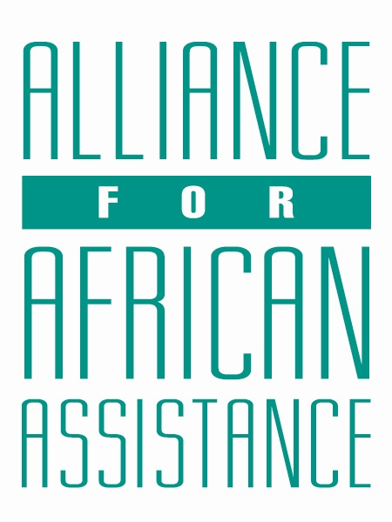
CSP Child Biography Form

PERSONAL INFORMATION
Child’s Village  (Where he/she currently lives) | LAYIBI KOR GAA
Child’s District  (Where he/she currently lives) | GULU DISTRICT
Child’s County  (Where he/she currently lives) | GULU CITY
Child’s Christian Name | DANIEL
Child’s Acholi Name | KICA
Child’s Date of Birth | 21/03/2007
Child’s Gender | MALE
Child’s Favorite Game/Activity | FOOTBALL

FAMILY INFORMATION
Mother’s Name | AYAA ALICE
Is mother alive? | DECEASED
Mother’s Profession, if living.
(If farming, which crops are presently being grown?)
Father’s Name | NYEKO ALFRED
Is father alive? | DECEASED
Father’s Profession, if living.
(If farming, which crops are presently being grown?)
If both parents are living, please give the reason that this child is in need of sponsorship. Based upon the family’s current needs and situation, what kind of activities might enable the parents to become self- sufficient and able to pay the costs of educating their children?
If parents have passed away, please give the reason for their passing (so long as the family is comfortable sharing this information. If the family is not comfortable sharing, please state this)
Guardian’s Name (If not parent(s) | AGENORWOT FLAVIA
Guardian’s relationship to the child (aunt, neighbor, grandfather, etc.) | ELDER SISTER, SHE IS JUST 21 YEARS
Guardian’s Profession (If farming, which crops are presently being grown?) | SHE DOES BUSINESS AT A SMALL-SCALE LEVEL. SHE SELLS BANANAS AND OVACADO ALONG THE ROAD SIDE JUST TO EARN SOME MONEY TO BUY WHAT TO EAT
Number of sisters with whom the child lives | 02
Number of brothers with whom the child lives | 01
Others with whom child lives | 01(SON TO THE SISTER)
Description of what the child helps with at home | HELPS THE SISTER WITH SELLING AND LOOKING AFTER THE YOUNG ONES
Additional Information | THE SISTER HAS A CHILD WITH DISABILITY (SPINAL CORD PROBLEM) AND SHE IS ALWAYS HOSPITALIZED WITH THE CHILD. THE CHILD IS NOW FOURS YEARS BUT CANNOT NEITHER SIT NOR STAND AND ONLY DEPENDS ON DRINKS FOR SURVIVAL. THIS HAS GREATLY AFFECTED HER SMALL-SCALE BUSINESS LEAVING HER WITH NO CAPACITY TO PAY FOR EDUCATION OF HER YOUNGER ONES.

ACADEMIC INFORMATION
Is child currently attending school? | YES
Name of School | LAYIBI GREEN PRIMARY SCHOOL
Class Level | P.6
Favorite Subject | SCIENCE
Future Dreams (Profession) | DOCTOR

